**BALLAD PROJECT PLAN**

**TEAM TRIAD**

**CALVIN DUPEE, HENRY MONTESANO III**

**10/13/21**

**Introduction**

**Scope and purpose of document**

(CD) This document contains the general outline, purpose, and feature set of the mobile application Ballad. The purpose of this is to keep us on track with our objectives for the application while also keeping it in accordance with our scope.

(HM) The Ballad mobile application is designed to serve as a new virtual environment for musicians around of the world to play and create music with one another. Musicians will be able to safely find and connect to other users through video or voice conferencing to play their favorite songs or collaborate on original songs. Ballad’s all-in-one toolkit provides everything a virtual musician needs to read music, keep tempo, record their sessions, and share their art with other artists. Through technology, Ballad allows users to create unique and memorable experiences and relationships with both accomplished musicians of the past and passionate artists of the future.

**System Scope**

*Problem/Opportunity Description (HM)*

In 2020, the COVID-19 pandemic upended the lives of millions of people around the world; one industry that was deeply affected was that of artists and musicians. No longer able to safely gather in person to collaborate on songs, musicians had to find workarounds to try to accomplish what was previously done in recording studios, schools, even backyards. These workarounds were sloppy at best, producing awkward jamming environments, poor recording outcomes, and overall apprehension and frustration for musicians. Ballad aims to provide a streamlined artistic environment that will relieve the stress of creating a virtual collaborative setting.

With all the disadvantages the pandemic has brought, it has also created opportunities for musicians to consider alternative ways of creating and sharing music without the need for physical interaction. As an all-in-one toolbox and social media platform, Ballad is the only application users will need to create music and share with other users. Focused on interactions between previously unacquainted users, Ballad presents both specialized and unrestricted ways for users to communicate and collaborate with artists without the barriers associated with differing locations and accessibility.

*Anticipated Business/Personal Benefits (RA)*

With this project, we hope to achieve a large user base that can come together to discuss, create music, and socialize with one another. We also hope to achieve a safe environment that users will have a good, and safe experience. We want to give aspiring musicians a platform to get their music out there, so others may see and enjoy.

One of the benefits is the ability to create music at any location with an internet connection. The free metronome and tuner are another benefit that allows musicians to properly get their timing down and tune their instruments. Also, the ability to save music is another benefit we expect to offer, with this benefit they can save their music and have the ability to distribute their own music. The ability to buy and sell sheet music is another great benefit that allows users to buy proper sheet music and sell ones that they created on their own.

*System Capabilities (CD)*

One of the main features of the app are the fully customizable user profiles. Some options include users’ name, what instruments the user plays, users' location, what genres the user likes to play, what the user feels their general skill level is, and what sheet music the user haves.

The primary feature of the app are the live jam sessions. This allows multiple musicians to connect with each other through either just audio or audio/video sessions to play songs together. Users can search for others based on their preferred genres, song choices, and purchased sheet music. A report system is in place for people who break our T.O.S.

The save & export feature is a kind of add on to the live jam sessions. Every session is recorded in real time should the user allow it and at the end of each session there will be an option to save it as one of multiple file types (ex: wav, flac, mp3, mp4 etc.). Each person’s audio can be recorded and saved separately for clarity. The files themselves are saved to a cloud database or directly the user’s computer.

The metronome and tuner are both more quality of life features. The metronome’s purpose is the same as a physical one, to time things properly. The tuner lets a user pick an instrument and desired pitch for said instrument, whenever a note is played it will display the input in relation to the desired one set.

A secondary feature built in is a music player. This allows any user to listen to previously recorded sessions, search for other users’ sessions that they made public, and functions as a normal media player.

The final feature is an in-app sheet music store that allows users to purchase sheet music and connect with others who own the same. Searching is based on what instruments are selected. Users can even upload their own if they so desire.

*System Context (CD & HM)*

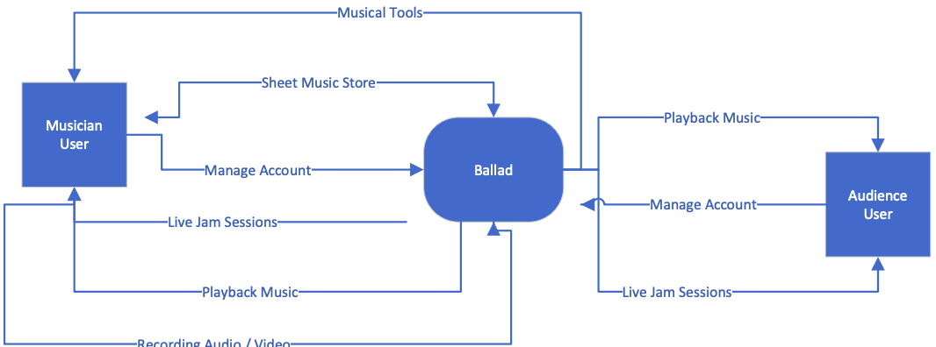

**Schedule (CD & HM – See Microsoft Project attachment on Blackboard)**

**Staff Organization (CD & HM)**

Team Triad has gone through multiple staff changes throughout the semester. Originally, the team was formed by Rudis Argueta, Calvin Dupee, and Henry Montesano III taking the role of Team Leader. Now having gone through a restaffing and two team member losses, Calvin and Henry are sharing the role of Team Leader.

**Tracking and Control Mechanisms (CD & HM)**

The team has stayed in frequent communication with each other through Slack to schedule meetings and discuss project ideas. Using Blackboard’s File Exchange as well as Office 365, the group will be able to make frequent alterations and additions to the project plan throughout its lifecycle. The team regularly meets every Tuesday afternoon to discuss the project deadlines for the week to stay on track and continue to further the project’s development.